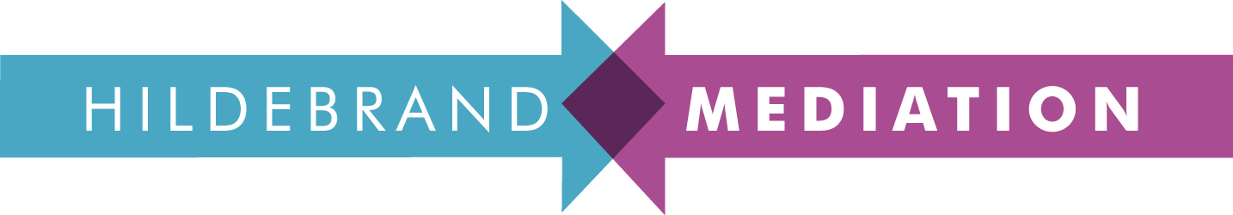

RESOLVING DISPUTES & CUTTING THE COST OF CONFLICT: MEDIATION FOR IN-HOUSE LAWYERS

A practical seminar with tips from the other side of the table, with leading mediator and former Channel 4/FilmFour Head of Business Affairs, Andrew Hildebrand.

'Probably the most interactive legal session I have ever attended ... and all the better for it.’

Learn how to:

- settle a dispute in a day
- use mediation to bump up your bottom line
- get the best deal in a mediation
- get what you want out of a meeting
- get a business relationship back on track
- prevent disputes escalating

Wednesday, 15th March 2017, 1.30 - 5pm at RIBA, 66 Portland Place, London, W1. £340, plus VAT per person.

To book: Call 0207 286 0272 or email me at andrew@hildebrandmediation.com

